GENERAL INFORMATION
SHELLS are available. Legal reloads permitted. If you want your empties, catch them. No one will be permitted to pick up empty hulls.
REFUNDS and ENTRIES: No entry fees, purses, or options will be refunded after the event has started. Also, no purses or options will be accepted after the first score sheet is posted.
AWARDS: Please notify handicappers at registration if you intend to shoot in a special category. You must shoot either class or category. No shooter may win more than one award per event.
SHOOT-OFFS: To the greatest extent possible, ties will be carried over, but if not they will be shot off. Shooters must be available or forfeit.
CONDUCT: The Great Falls Trap Club reserves the right to refuse entry or withdraw any contestant who in any way interferes with the safety, harmony and enjoyment of this shoot.
CLASS WINNERS: Winners will move up a class on next days shoot.

SAFETY FIRST
- All guns must be unloaded, with action open, at all times, EXCEPT on the firing line or in a gun rack. Guns will not be shouldered in the clubhouse.
- No tracking of targets behind a shooting squad is permitted.
- In singles shooting, only one shell may be inserted in the gun (for doubles, two shells) and only when on the firing line. No gun should contain a live shell, an empty shell, a snap cap or any similar device while the shooter is moving from station to station.
- As a safety precaution, test shots will not be permitted.
- Watch the muzzle, keep it pointed in a safe direction.
- Alcohol and drugs impair judgment and the ATA Rules pertaining to the usage of alcohol and/or drugs will be enforced by Shoot Management. All persons including competitors, referee/scorers, and trap personnel must wear appropriate eye and hearing protection while on the trap field. Failure to comply may result in disqualification.
- The club management may disqualify a contestant for any violation of these rules.
- By entering the competition every person agrees to accept all official decisions and to abide by the current ATA Rules.

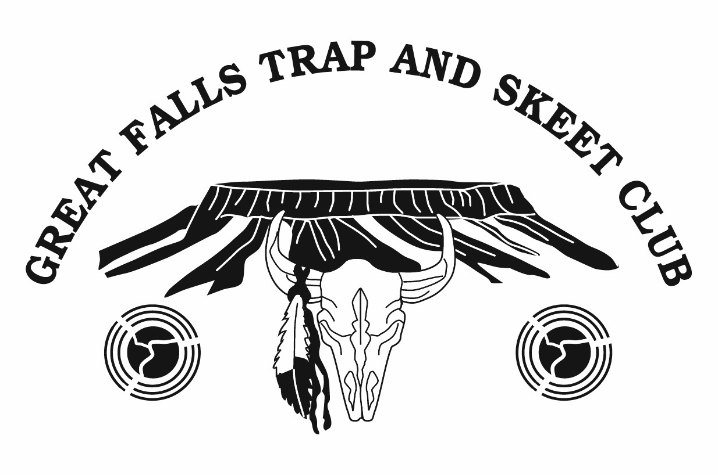
PO Box 1058
Great Falls, MT 59403
406•453•5032

RICK COOK MEMORIAL SHOOT
2024

May 18th & 19th
at the
Great Falls Trap Club

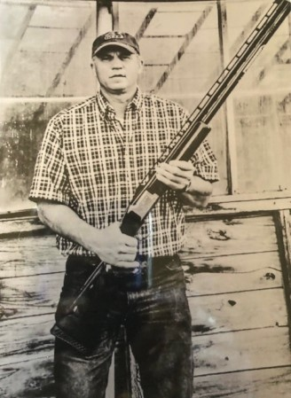
$3000+ IN JACKPOTS
$2000+ IN ADDED MONEY

GREAT FALLS TRAP CLUB
(406) 453-5032

Jim Burman Mike Houseman
(406) 468-2751 (406) 899-7783

RV Spots Available
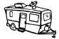
with Electricity
DAILY EVENT TROPHIES
EVENT 3/4
Winner each class A, B, C
EVENT 1/5
Winner each class AA, A, B, C, D
Vet, Jr., Lady and New Shooter
EVENT 2/6
Champion, Runner Up, 3rd, 4th
HIGH OVERALL
(total of both days)

$2020 Added Money
$1010 per day
Singles ($350) Awarded High Gun
$70 per class AA-D each day
Doubles ($330) Awarded High Gun
$110 per class A-C each day
Handicap ($330) Awarded Champion/Runner Up $230/100 each day
Ties will be divided
DONATED BY RICK COOK FAMILY, FRIENDS
& GREAT FALLS TRAP & SKEET CLUB

House’s Buck-A-Bird
For Montana AIM Youth
17 & Under

100 Straight in either Event 1 or Event 5
$100 prize donated
by Mike & Deby Houseman
Saturday May 18, 2024
Saturday May 18, 2024
Start Time 10:00 am
EVENT 1 100 Singles
ATA Day $ 4.00
Targets & MSTA FEES $35.00
Lewis Class $10.00
4 Corners Purse $ 4.00
EVENT 2 100 Handicap
Targets & MSTA FEES $35.00
25’s $16.00
50’s $18.00
Lewis Class $10.00
Jackpots $12.00
EVENT 3 50 Pair Doubles
Targets & MSTA FEES  Lewis Class  Ricky’s Doubles Pots | $35.00  $10.00  $ 4.00
Classifications
Singles Doubles
AA - 97 & Over A – 89 & over
A - 94 & under 97 B – 83 & under 89
B - 91 & under 94 C – under 83
C - 88 & under 91
D - Under 88
To the greatest extent possible, ties will be carried over.
ATA registration: This certifies that the Great Falls Trap Club is authorized to hold a registered shoot on May 18 & 19, 2024. Scores will be included in the ATA official records and ATA rules will govern this shoot.
Targets will be set to ATA Standards.
Sunday May 19, 2024
Start Time 9:00 am
EVENT 4 50 Pair Doubles
ATA Day  Targets & MSTA FEES Lewis Class  Ricky’s Doubles Pots  EVENT 5 100 Singles  Targets & MSTA FEES Lewis Class  4 Corners Purse  EVENT 6 100 Handicap  Targets & MSTA FEES  25’s  50’s  Lewis Class  Jackpots | $ 4.00 $35.00  $10.00 $ 4.00  $35.00  $10.00 $ 4.00  $35.00  $16.00  $18.00  $10.00  $12.00
Great Falls Trap Club Jackpots
Lane’s Pot of Silver 1st & 2nd 25’s Taco John’s Pot 1st & 3rd 25’s  George Hipps Pot 1st & 4th 25’s Roger Stenson Pot 2nd & 3rd 25’s  Charlie Getten Pot 2nd & 4th 25’s Dennis Castle Pot 3rd & 4th 25’s  Ricky’s Doubles Pots 1st $124.00 | $410.00 $300.00  $359.00  $413.00  $235.00  $178.00  2nd $198.00
Class A 50/50, Class B 49/50, Class C 48/50
4 Corners Pot 1st and last 25’s of Singles & Handi $1135.00 Winner takes 1/2, day fees included.

Breakfast & Lunch available Saturday & Sunday
ROSA HUGG
Dr. Kirk A Seekins • Dr. Grant W. Smith • & Associates
SKYLINE VETERINARY CLINIC
www.vet4yourpet.com
15th Street North • Junction Havre Highway • and Bootlegger Trail
P.O. Box 2905 • Great Falls, MT 59403 • (406) 761-8282

